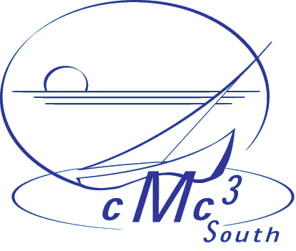

March 16, 2004

To: Bruce Yoshiwara, L.A. Pierce College

Dear Bruce,

Thank you very much for being part of the CMC3 South 19th annual conference: “Beyond Eighteen and Feeling Prime”.
We had a great turnout, of 278 attendees, one of the highest ever. The evaluations show great satisfaction with the conference. We owe it to you, the presenters, that we had a program with a broad range of excellent choices.
The CMC3-South Board is delighted that you agreed to share your expertise with our members, and thanks
you deeply for your commitment to your profession.

Sincerely,

Ignacio Alarcon
Santa Barbara City College
721 Cliff Dr
Santa Barbara, CA 93109
Phone: (805) 965 – 0581 ext 2559
Email: alarcon@sbcc.edu

